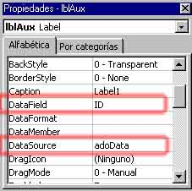

Now is good to know more about the properties of the AdoDC. Learn more about it in the next sep

Properties of the AdoDC in DesingTime

EofAction: It indicate to the control what it do when it become to the end of the register. The option are adDoMoveLast o adStayEOF these are similar: the control when it goes to the end of the register it will be quiet in the end; there is another opction, adDoAddNew, that indicates to the control that when it goes to the end it will add a new empty register that it can be edited. If you wanna edit a register read the next part.

MaxRecords: Indicate to the control how many register load the AdoDC. It is useful when we have a largest database and we are limited in memory.

Mode: Is the mode that the database will be open: it can be read only, read/write, share mode, etc.

Improvement I: Edit a register

6.- To improve our program we can add the option to edit the registers. To do this replace all the labels with textbox (you can also don’t touch the labels and only add the textboxes).

7.- Ok, now that we hace textboxes in the form repeat the process explained in the step 5: Connect the AdoDC to controls to show the linked data.

8.- It is ready, run the program and check the new improvement. Travel trought the register and when you wanna edit, change the info in the textboxes and then move to another register to save our change.

Improvement II: Add and edit a new register

9.- To do this, only change the EofAction property of the AdoDC to adDoAddNew. It is ready. Run the program and then when you where in the end of registers do click in the next button of the AdoDC: a new empty register will be appears. Edit some fields and then move to another register to auto save the changes.

Improvement III: Show the data in a sheet like Excel

10.- To do this, first we must add a DataGrid control in our form.

11.- Then, link this control to the AdoDC. To do this you must go to the DataSource property and select the name of the AdoDC that you link to your database.

12.- The next step is to add the quantity of columns same as the quantity of fields that we want to show. To do this do right-click in the DataGrid and select Modify, (now we are in the edit mode of the datagrid) then do again right-click and select insert, repeat it as many columns you want. If you don’t wanna to do all this harder work, you could select with right-click the Recovery Field option. With this option the DataGrid automatically add the columns and link every column with a diferent field.
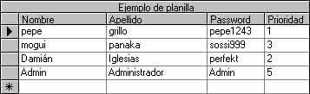
13.- Only if you didn’t select Recovery Fields, select Properties... with a right-click in the DataGrid. In this new window we will config the DataGrid as we want.

To start, in the General tab, we can add a title to the control with the Caption property; we can allow to the user to add new register checking the AllowAddNew option; we could allow to the database to autoupdate, it allow to the user to edit the registers, it can be done with AllowUpdate option; we could allow to the user to delete the register with AllowDelete option; we can show/hide the titles for every field (column) with ColumnHeader and we can enable/disable the datagrid with Enabled.
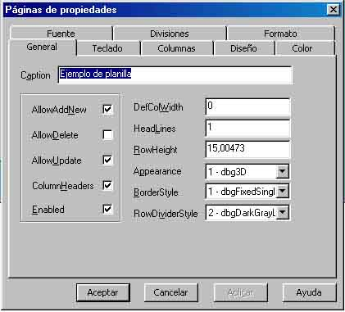
In the Keyboard tab we can indicate how the navigation is trought the DataGrid with the keyboard: if we can use the keyboard arrows or what happened when we press the Tab key.

The Columns tab allow to link every column with a field. In the combo Columns we must select which column we want to link and then in the two textboxs we can write the caption of the column and in the DataField textbox we must select the name of the field that we want to show.

Then in the Desing, Color and Font tabs we can select the visual presentation of the control.

In the Format tab we can select how every column show the data (like a date, like a time, etc). If we select the format Currency the column will display the data like this “$ 123,45”, or if we select Boolean the data can be show as True or False instead of 0 and –1, also we could select the format checkBox showing a litle checkboxs in every register.

14.- Finally, you can adjust the size of the columns doing right-click in the DataGrid and selecting Edit. When you finish, you can run the program and test this improvement.

Improvement IV: A search engine using filters

Now we must use the fingers to write code. There is two metods to search: using the Find metod or using Filtres. The last one is better than Find then i will use Filtres.

15.- Now we must add a textBox that will be used to enter the search string, and we must add two Command Buttons, one is to start search and the other is to remove the filter (showing all the registers). Change the name of these controls to txtFind, cmdFind y cmdShowAll or similar.

16.- In next this is the search struct:

AdoDC.Recordset.Filter = “fieldName = 'José’”
AdoDC.Recordset.Filter = “fieldName Like '*José*'”
AdoDC.Recordset.Filter = “fieldName = 'José’ AND fieldSecondName = ‘Perez’”

In the propertys of the AdoDC we have a collection called RecordSet. This collection is a reference of the Table of our Database that we link with the AdoDC, and inside of this collectin we have the Filter property. This property is a String that indicate what register will be show. Over this paragraph we have three examples. The first one say to the AdoDC to import only the registers that they have in the field named fieldNamed only the string José. In the second example, the AdoDC will import the register that in the field called campoNombre have in his string the word José also will import a register that have the string xxxJoséxxx or José Pablo. The last example show how you can use or and and operators to import the resgiters with múltiple condition. In this case the Ado will import only the registers that have a person called José Perez.

To bear in mind you have to know that the registers imported by the Ado control after a filter will stay until we set the AdoDC.Recordset.Filter to nothing (“”). The button cmdShowAll that we added before will be the one who will set the filter to nothing.

This is the example code of all I said about the filter:

Private Sub cmdFind_Click()
' We filter all the registers where the field Nombre have the string of txtFind
' Nombre is the name of the field in our database of Access
' To do múltiple field search use the text of a textbox like this:
' adoData.Recordset.Filter = txtCampo & " Like '*" & txtFind & "*'"
adoData.Recordset.Filter = "Nombre Like '*" & txtFind & "*'"
End Sub

Private Sub cmdShowAll_Click()
' Show all register (we clear the filter)
adoData.Recordset.Filter = ""
' Refresh to really show all
adoData.Refresh
End Sub

Run the program and test it.

Properties from code of AdoDC

.RecordSource: Allow to change the linked table to another

.Caption: Allow to change the title of the AdoDC to another with more info.

.Recordset: This is a collection with properties and metods doing reference to a table of Access.

.Recordset.AbsolutePosition: Indicates the number of the present register.

.Recordset.AddNew: Make a new empty register.

.Recordset.Close: Close the database.

.Recordset.Delete: Erase the present register.

.Recordset.Fields: With this you could read the data of a register. To read the data do this:

adoData.Recordset.Fields("fieldName").Value: Returns the data of the field fieldName of the present register.

adoData.Recordset!nombreCampo: Hace It do the same as before but it is shorter.

.Recordset.Move
.Recordset.MoveFirst
.Recordset.MoveLast
.Recordset.MoveNext: All this metods allow to move trought the registers and are useful to replace tha AdoDC with another controls to make our program enviroment looks cool.

.Recordset.RecordCount: Returns the grand total of imported registers.

.Recordset.Save: Save and refresh the database.

.Recordset.Sort: Sort the registers. Use like this adoDC.Recordset.Sort = “fieldName”. Or adoDC.Recordset.Sort = “DESC fieldName” to descending sort.

.Recordset.Update: Refresh the imported table.

Frequently errors

1.- When I compiled a program and shell the exe, show a critical Windows error message.

This problem is caused because when we edit the format of a column in datagrid we select the Boolean format and we edit the third state of a boolean data. Put nothing to this third state and try again.

Versión Visual Basic: 6.0 Spanish
Versión DataBase: Access 2000 converted to Access 97

Historia del tutorial

v 0.1

Primera vesión

V 0.2

- Se agregó la sección errores frecuentes con 1 solo problema
- Se agregó el historial del tutorial

Se corrigió un error en el procedimiento cmdShowAll_Clic() en la sección de búsqueda por filtrado (faltaba agregar la linea adoData.Refresh que hace que se visualicen los datos.

Hecho en Agentina

Fin del tutorial por ahora

Bueno, por ahora ya esta bastante completo la primera entrega de este tipo de tutoriales. Estaría bueno, a partir de haber completado todos los pasos, empezar a experimentar cambiando las propiedades, o quizás tratando de reemplazar el AdoDC por controles gráficos usando código. También está bueno hacer sistemas de búsquedas o tratar de reemplazar las fuentes de los controles y tamaños para hacer algo más copado.

Quizás trate de hacer tutoriales de otras cosas que sepa mejor pero primero quiero ver si sirve bien este. Si se entiende o parece que hacen faltan más cosas digan al e-mail smfavaro@hotmail.com.

